Howell Graves Preschool

PARENT HANDBOOK
2022-2023

Sheneta Smith, Ed.S.
Principal

“Love to Learn”

3201 Alabama Avenue, Muscle Shoals, Al 35661
*Office 256-389-2630
*Fax 256-389-2632

This version of the HGP Student Handbook is up-to-date as of January 7, 2022. Should any changes to the handbook be made for the 2022-2023 school year, the Principal will notify parents in writing prior to the first day of school.

In the event of a conflict, discrepancy, or inconsistency between the Student Handbook and The Policies of the Muscle Shoals Board of Education, the Board Policy Manual shall take precedence and prevail.

A LETTER FROM THE PRINCIPAL
2022-2023

Dear Parents,

I would like to welcome you to Howell Graves Preschool. I am very excited about being your principal, and I am willing to assist you in any way that I can.

Our goal is to serve you in such a way that your child will have an enjoyable experience and be eager to attend school each day. Cooperation between the school and home is of utmost importance in accomplishing this goal. We invite our parents to participate in their children’s learning experiences throughout this school year.

This handbook is provided to inform you and your child of basic policies and procedures that pertain to Howell Graves Preschool. The faculty and I are looking forward with enthusiasm to the new school year. Our mission is to make education a fun-filled adventure.

Sincerely,

Sheneta Smith, Ed.S
Principal,
Howell Graves Preschool

Eight Ways to Prepare Your Child for Kindergarten

- Read books every day. Point out letters that you recognize and say its name.
- Practice letter and sound recognition. Practice saying the letters and their sounds every day.
- Practice number recognition. Count objects up to 20 every day. Practice counting backwards from 10.
- Print first name with only the first letter capitalized and be able to recognize last name.
- Develop fine motor skills: holding a pencil, coloring, cutting with scissors and learning to tie shoes.
- Learn to follow two-step instructions: “Please go get your shoes and then put them on.”
- Talk about social skills: sharing, taking turns, positive words, and handling anger.
- Help your child take responsibility: clean up messes, dress themselves, get their own socks.

GOALS

Children will have opportunities to:

- Develop a positive self-image.
2. Enhance their social and emotional development.
3. Expand early concepts, independent thinking, and problem solving.
4. Make choices.
5. Improve all their communication skills.
6. Expand their interest in the natural world.
7. Advance in the development of fundamental motor skills and abilities.
8. Have their individual mental, social, emotional and physical needs identified.
9. Increase their capability for self-discipline.
10. Further their development of respect for others.
11. Promote their aesthetic appreciation and expression in drama, art, and music.
12. Nurture their creativity.
Parental involvement will include opportunities for:
1. Participation in education programs.
- Active participation in their children's education.
- Regular communication between parents and school personnel.

It is the official policy of Howell Graves Preschool that no person shall be discriminated against on the grounds of race, color, sex, disability, religion, national origin, or age, nor be excluded from participation in, be denied the benefits of, or be subjected to discrimination under any program, activity or employment (Board Policy GAAA).

OUR BELIEFS:

- Learning is our primary focus.
- All students can learn regardless of individual differences.
- Student learning is promoted through a safe, positive and physically comfortable
environment.
- Instruction and decision-making are data driven.
- Student learning is maximized through individualized, developmentally appropriate instruction and challenging problem solving.

- Technology implementation is beneficial to produce self-confident, life-long learners.

- Parental and community involvement plays a major role in the success of our school.

HOWELL GRAVES PRESCHOOL
SCHOOL MOTTO:

“Love to Learn”

MISSION STATEMENT:
MUSCLE SHOALS CITY SCHOOLS

The mission of Muscle Shoals City Schools, a progressive system of excellence, is to provide innovative opportunities for all students to obtain wisdom, to build character, and to achieve their greatest potential through challenging expectations that create a vision for a successful future.

A

ARRIVAL TIME

Parents are requested to see that their child arrives at school on time (7:35 a.m.); however, children should not arrive before 7:15 a.m. If you choose to park and walk your child over in the mornings, please do not park in the spaces marked for faculty. We ask that you park in the spaces that are blank or that are marked for visitors. Please make sure your child arrives on time to prevent tardies.

ATTENDANCE POLICY
Regular attendance is essential for a student's successful progress in the instructional program. In accordance with state law, only the following absences shall be considered excused absences, provided that parental confirmation of the reason for the absence has been received:

A. Illness
B. Inclement weather which would be dangerous to the life or health of the pupil if he attended school.
C. Legal quarantine, death in the immediate family, emergency conditions as determined by the superintendent or principal.

IF A STUDENT IS ABSENT, HE/SHE MUST BRING A WRITTEN EXCUSE FOR BEING ABSENT WITHIN THREE (3) DAYS OF THE ABSENCE. If the excuse is not brought within three days after returning to school, the absence(s) become unexcused. The excuse should include the date(s) of the absence and the specific reasons for the absence(s). Seven parent notes will be accepted each school year as excuses. Doctor’s excuses will be needed for any additional absence after seven parent notes. The teacher must keep each excuse on file to be turned in to the attendance committee at the closing of school.

The student must be in attendance 160 days in order to receive credit for academic work. In extraordinary circumstances, the student may appeal to the principal.
A child must have attended school 180 days without having been tardy, having checked out, or having left early to obtain perfect attendance.

B

BIRTHDAY PARTIES
Birthday parties with invitations and gifts are not permissible. However, a healthy or special snack may be shared at snack time on a child's or teacher's birthday. You may check with your child’s teacher as to when is the best time to bring a special snack. Students are not to pass out birthday invitations while at school unless every child in the classroom is invited. Students are not allowed to have gifts (balloons, stuffed animals, etc.) delivered to school (birthdays, Valentine’s Day, etc.)

BOARD POLICY MANUAL
The Muscle Shoals City Board Policy Manual can be found on the district website at www.mscs.k12.al.us
The Muscle Shoals City Board of Education does not discriminate on the basis of race, color, national origin, sex, disability, religion, or age in its programs and activities and provides equal access to the Boy Scouts and other designated youth groups.

C

CAFETERIA MANAGER
Kelly Uhlman is our CNP manager. If there is a problem concerning your child’s lunch or lunch account, please feel free to call 256-389-2635. The staff enjoys serving children and wants to make school lunch a pleasant one. All other questions concerning child nutrition need to be directed to the CNP Director, Mrs. Blake Stone at the Board of Education 256-389-2600 Ext. 1010.

Applications for Free and Reduced priced meals. If you need a free/reduced lunch for your child, a form will be available in the school office. Kindergarten and new Muscle Shoals students MUST be approved before a free or reduced price lunch can be served. An application is always provided at registration to be completed as soon as possible. You may also fill the form out on the district website at My School Apps.

Good Nutrition. Children will not be allowed to bring candy or gum to school. Only 100% juice, milk, or water should be brought in a child's thermos for lunch. No soft drinks. We want to insure good nutrition for all students.

Fast Food Meals are not permitted for our students in our lunchroom. Please help encourage nutritious meals. If fast food items are brought by parents to school for their consumption, items must be in a plain bag.

Snack. We encourage good nutritious habits at all times. Please send fruit or raw vegetables for your child's snack. Peanut-butter crackers and baked chips are okay. Please do not send any drinks with red dye. They stain our floors. NO CANDY, COOKIES, CAKE (now State Law).

CHILD NUTRITION PROGRAM
Our CNP Director, Mrs. Blake Stone, has written information for parents of the 2022-2023 HGP students. Kid-friendly meals are available in the cafeteria every school day. Weather days and shortened school days may require a change in the usual meal service times and offerings. School menu breakfast and lunch menus and prices are posted on the school website under “School Menu”.

Parents are always welcome to have lunch. However, we ask that students not have guests visit for lunch for the first six weeks of school. We need this time to get our students accustomed to school before having visitors for lunch. As a courtesy to the lunchroom staff, please call the school secretary by 9:00 a.m. on the day you plan to eat.

It is the parent’s responsibility to make sure enough money is available to pay for meals purchased at school. Please-NO CHARGES on lunches or on extra food items. Parents will be notified if a child needs meal money.

Menus will be posted once a month on the Muscle Shoals City Schools website. (www.mscs.k12.al.us)

Make meal account checks for the correct amount and make payable to Howell Graves Preschool. Please place money in an envelope labeled with child's name, CNP computer number and amount of money enclosed. Never send money to school without an envelope. Labeling the envelope enables the CNP staff to determine to whom it belongs. This year, our system is offering a payment method, MySchoolBucks, which allows parents to deposit meal money on-line. More information about this service will be provided at the beginning of school.
If a student brings a lunch or needs milk for a lunch or snack, this can be purchased separately. Milk is $.50.

If a child cannot drink milk, a substitution of fruit juice or water can be made only if a doctor's prescription is brought to the cafeteria manager and kept on file.

If your child has any food allergy, you MUST notify the office, child’s teacher, school nurse and lunchroom manager, and bring a doctor’s prescription before substitutions will be provided.

CHECK IN - CHECK OUT PROCEDURES
No student shall enter school after 7:40 or leave school before 2:25 without checking in or out through the school office. A student must obtain a classroom pass to enter his/her classroom after 7:40. Parents are asked NOT to accompany a child to their classroom when tardy. A parent/guardian must check the student out through the office if he/she is to leave school before 2:25. Only those persons listed on the student’s emergency card, emergency check-out list or those with a security card will be allowed to check out the child.

- Unexcused check-ins and unexcused check-outs will be considered as tardies. Check-ins and check-outs are considered excused for the same reasons as excused absences.
- Students who obtain more than 10 tardies per semester in the elementary grades will be expected to attend Saturday School following the 11th tardy and every Saturday thereafter for each additional tardy. Elementary students must be accompanied by a parent or legal guardian. Saturday School begins at 8:00 a.m. and dismisses at 11:30 a.m. If the student and parent or legal guardian are tardy for Saturday School, it will be considered another tardy and will have to be made up. If a student and parent or legal guardian do not attend Saturday School as scheduled, the student will be sent to In-School Suspension on the Tuesday or date assigned following the Saturday scheduled for Saturday School. Tardy accumulation is operated on a semester basis.
- Check-outs within 30 minutes of dismissal time will only be allowed due to emergency situations (as determined by school administration).

Please do NOT park in the drive through lanes when checking students in/out of school. Please park on the road or in the parking lot and walk over to check your child in/out of school. If you get blocked in there is not guarantee you will be able to get out of line until we dismiss.

CLASS PARTIES
Classes may schedule four (4) parties during the school year. Parties last approximately 30 minutes and are usually held on the school grounds. Party dates are as follows:

Christmas Party: December 15, 2022-1:30 p.m.
Valentine’s Party: February 14, 2023-1:30 p.m.
Easter Party: TBA
End of the Year Party: TBA

CODE OF CONDUCT
The CODE OF CONDUCT FOR MUSCLE SHOALS CITY SCHOOLS is designed to assist school personnel, parents, and students in maintaining an environment conducive to learning and to accomplish the following:

1. Describe the responsibilities of school personnel, parent/guardian and students.

2. Standardize procedures for administering formal disciplinary actions.

3. Explain due process procedures relative to disciplinary action.
Please keep your Code of Conduct on hand for easy access.

CHILD CUSTODY
Child custody papers must be filed in the guidance counselor and principal’s office if specific rules and regulations are to be followed. It is mandatory that school personnel abide by each child’s custody agreement. We ask that parents work together to keep Howell Graves Preschool free of parents’ personal conflicts.

CHILD FIND
The Muscle Shoals City School System serves children within our jurisdiction who need special education and related services to benefit from their education. Please contact the Student Services office at the Muscle Shoals Board of Education at 256-389-2697 if your child has a disability and is in need of these services.

D

DEPARTURE TIME
Parents are requested to pick their children up each day at dismissal time (2:25 p.m.). If students are not picked up on time, someone must remain on duty to watch them. Muscle Shoals Board Policy states that school personnel is responsible for child supervision for 20 minutes only after school dismisses. NO CHILD SHOULD BE PICKED UP LATER THAN 2:45 FOR ANY REASON. After the first week of school we ask that you do not park in the two pick-up lanes in front of the school until 1:30 p.m. Please do NOT park in the pick-up lanes if you do not have your child’s pick-up tag with you. You will need to park in the parking lot and bring your identification to the office.

DISCIPLINE
Each teacher will include their students in developing classroom rules. We believe this will aid in the children's understanding and compliance of their classroom rules. We want our children to learn responsibility to self and others since they will be our leaders of tomorrow. For additional information concerning discipline, please refer to Muscle Shoals City Schools Code of Conduct.

The following are HGP School Rules:

1. Show respect and consideration for your teachers and classmates.

2. Keep hands, feet and objects to yourself.

3. Act in a safe, responsible, and non-disruptive manner.

4. Be respectful of the property of others.

FIGHTING MAY RESULT IN POSSIBLE SUSPENSION FROM SCHOOL with principal's discretion. If the child is suspended, the child's parents will be notified immediately (if possible) and requested to pick up their child.

If the school is unable to contact the parents, a letter of suspension will be sent home with the child and a copy will be mailed to the parents. The child will then be suspended the following school day.

Please refer to the Code of Conduct for School Personnel, Parents and Students for the Muscle Shoals City Schools for more discipline information.

E

EMERGENCY CHECKOUT CARD
Each teacher will have a list of persons who may checkout your child in an emergency situation. Please keep your list current. Names may be added or deleted by a parent or guardian only and must be done in person in the school office.

EMERGENCY PROCEDURE
School Delay- Depending on the length of our morning delay (1 hour, two hours, etc.), Howell Graves beginning time will be 8:35 am (1 hour delay) 9:35 am (2 hour delay). Other schools in our system will convene at different beginning times.
Early School Dismissal - The reason for early dismissal is usually weather related. Circumstances could exist that would necessitate schools dismissing as quickly as possible before extreme weather reaches our area. For early dismissal, all Muscle Shoals City Schools will dismiss at one, uniform time.

1st: LISTEN TO THE LOCAL RADIO AND TV STATIONS. As soon as we receive word that schools will be dismissed, it will be announced on local radio and television stations. We have implemented system-wide calling which should notify you of school closings. You will by notified according the phone number (number indicated on registration form) you have given to the school. Please inform the office and any changes in your phone numbers.

2nd: Do not call the school to ask if school will be dismissed. We will not know about an early dismissal until we receive official word from the superintendent. However, if you suspect that school might be dismissed early or if school will not be in session because of weather, listen to the local radio and television stations. We would like to encourage you to not check out your child early. We can clear our campus in 10 to 15 minutes if students are picked up in the usual manner.

3rd: Children are checked out from their classroom instead of the office in
emergency situations. A PARENT OR GUARDIAN MUST SIGN THE EMERGENCY CHECKOUT SHEET IN THE CLASSROOM. Names on the emergency check-out list must be changed or added only by a parent in the school office.

Thank you for your continued cooperation and support of Howell Graves Preschool.

EXTENDED DAY PROGRAM
Howell Graves offers an excellent after-school program. Extended Day is in operation every day that school is in session. Please call the Community Education Director at 256-389-2639 for more information.

F

FAMILY EDUCATIONAL TRIPS
You may want to take your child out of school to accompany you on an out-of-town educational trip or vacation. Permission for such a trip may be granted by the principal if your child is not in danger of exceeding 20 absences. Your child must, also, complete any required class work before making the trip. Please contact the principal for permission for such a trip. Otherwise, the absence will be unexcused.

FIELD TRIPS
Field trips are an exceptional way to help enhance a child's development. Although parents sign an inner system registration form, an additional permission slip will be sent home prior to each field trip. If this permission slip is not returned prior to departing on the field trip, the student will NOT be allowed to attend. Adequate supervision is required at all times during the field trips.

G

GIFTED EDUCATION
Gifted students are those who perform at or who have demonstrated the potential to perform at high levels in academic or creative fields when compared to others of their age, experience, or environment. These students require services not ordinarily provided by the regular school program. Students possessing these abilities can be found in all populations, across all economic strata, and in all areas of human endeavor.

Teachers, counselors, administrators, parents, or guardians, peers, self, or any other individuals with knowledge of the student’s abilities may refer a student. Additionally, all second grade students will be observed as potential gifted referrals using a gifted behavior checklist.

For each student referred, information is gathered in the areas of Aptitude, Characteristics, and Performance. The information is entered on a matrix where points are assigned according to established criteria. The total number of points earned determines if the student qualifies for gifted services.

To make a referral, contact the Supervisor of Student Services at the Muscle Shoals Board of Education or the Gifted Education Specialist at McBride Elementary School.

GRADUATION
Howell Graves Preschool does not participate in a graduation ceremony for our students. The graduation mentioned on the school-wide calendar refers to Muscle Shoals High School’s ceremony.

H

HEAD LICE
Head lice are a common problem in Alabama school children. Education, for all involved, should help in early identification of cases and understanding of the need for treatment. Head lice is incapable of hopping, jumping or flying, but are primarily acquired by direct contact with the infested person. Wearing clothing such as a hat, coat or scarf that was worn by an infested person, using an infested comb or brush, or lying on contaminated furniture, carpeting or bedding can also result in becoming infested.

Printed materials relative to the treatment of head lice is available to every parent of a child in Grades K-6. If, during the screening process or individual inspections of students suspected of being infested with head lice contamination is confirmed, the following procedure will be followed.

1. An infested child will be removed from class and the parent or guardian will be called to take the child home for treatment. Care will be taken not to embarrass the child.

2. After the infested child has been given the first treatment and nits have been manually removed, the parent should bring the child to school and wait for completion of an examination by a school official. If the student is not nit free, he/she will not be readmitted to school.

3. A second inspection seven to ten days later may need to be given by a school official.

HELPING SCHOOLS TAGS
One way that you, as a parent, can support education and make a contribution to Howell Graves Preschool is to purchase a Helping Schools tag. The tag cost $15.00 extra and the entire amount will be given to the school of your choice. You can also have these tags personalized (up to 6 characters). We encourage you to purchase one of these tags to help Howell Graves Preschool.

HOLIDAY LUNCH SCHEDULE
2022-2023
*Dates are subject to change

Thanksgiving-Nov. 3, 2022 Christmas-Dec. 1, 2022 Valentine’s-Feb. 9, 2023
Alligator Elephant Toucan
Rhino Panda Kangaroo
Monkey Lion Leopard Bear Owl Giraffe
Zebra

HOMEROOM PARENTS
Two (2) homeroom parents are to be named for each class. These parents will be responsible for planning and delegating responsibilities for the class parties as well as our “extra” activities. Parents, please realize that it takes everyone working together to have successful, enjoyable parties and school functions. If you are not a homeroom parent, please help in any way that you can.

HOURS
School hours for the first full week of school are 7:35 to 12:00 p.m. Doors open at 7:15 if you need to come early. Teachers will report at 7:15 during this first week. School hours for the rest of the year are 7:35 a.m., first bell—7:40 a.m., tardy bell. School dismisses at 2:25 p.m.

I

ILLNESS
If a child has an elevated temperature (over 100 degrees), he/she should be removed from the school setting. The parent must keep the student home until the temperature is normal for 24 hours.

INNER SYSTEM TRAVEL
At the beginning of each year, parents are asked to grant permission for their child to participate in inner system travel without signing individual permission forms. This is done on the registration form.

INSPECTION OF STUDENT RECORDS
Official student records, files, and data may be inspected by parents or legal guardians of a particular student. Students who are over 18 years of age may inspect their own records. These procedures shall be followed in making inspections of student records:

1. All requests for inspecting student records shall be made in writing on forms provided by the Muscle Shoals Board of Education. Permission shall be granted to eligible persons within a reasonable amount of time but in no case more than 45 days after making the request.

2. The request shall be signed by the person making the request and shall be kept permanently with the file folder of the student. This shall be available to parents, legal guardians, students who are 19 and older, and to school personnel who have access to these files.

3. When a student has attained 18 years of age or is attending a post secondary education institution (full time), the permission or consent required of the rights accorded to the parents shall thereafter only be required of and accorded to the student.

K

KINDERGARTEN ASSESSMENT TESTS
All assessment data is used to guide instruction. Students will be assessed informally (weekly tests, end of unit tests, etc…) in reading (Fountas and Pinella) and in math (enVision Math). These assessments are used to monitor understanding and for grading purposes. In addition, we have two, formal assessments that we administer to our student.
STAR
STAR Early Literacy is a diagnostic assessment. It measures the emerging reading skills of students in grades pre-K through 3. It is administered three times a year (beginning, middle, and end).
NEXT STEPS GUIDED READING is an easy four-step process that helps teacher pinpoint students’ guided reading levels and provide in-depth instruction quickly. The four steps deliver rich information about student’s reading interests and motivation along with their current proficiency in word knowledge, phonics, spelling, fluency and comprehension. It is administered three times a year (beginning, middle and end).

L

LIBRARY
Students with outstanding books (overdue, lost, stolen or damages) are not eligible to check out materials until the book is paid for or checked into the library. Full replacement cost will be charged for all lost or damaged books.

LOST AND FOUND
All personal possessions should be clearly labeled with the first and last name of the child. This is especially important for items of clothing. Items that have been lost and found will be kept in the office. At the end of the school year, all items remaining in lost and found will be donated to a local charity.

M

MEDICATION
If your child needs to receive medication at school, you will have to complete a medication form. If the medication is prescribed by a physician, you must see that the child’s doctor signs the form. If the medication is over-the-counter, you still have to complete the medication form for the office personnel to be able to administer the medication. If your child has need for medication, always see our office personnel for the forms.

If your child has a medical condition that requires special attention (treatment) such as asthma, seizures, etc. you must arrange to complete a Medical Plan for him/her with a school nurse. This should be done as soon as school begins. The medication guidelines are on the next page.

All medications must be picked up by a parent by the last day of school. We will send a letter home to remind you of this.

MEDICATION GUIDELINES FOR STUDENTS
The medication administration procedures for Muscle Shoals City Schools have been written to comply with the recommendations from the State Department of Education. Please read all of the below information carefully. If your child will be taking medication during school hours, you may pick up the necessary form in the school office.

- All medication for children in grades K-12, (prescription/non-prescription), should be brought into the school office by an adult. Students should not have medication in their possession. EXCEPTION: Students who must carry asthma inhalers as prescribed by a physician.
- Controlled medications, such as Ritalin, will be counted by office personnel when brought into the office.
- All medication (prescription/non-prescription), must have a medication release form completed and on file in the office prior to medication administration by school personnel. The form must be signed by a parent or guardian for non-prescription and by the physician for prescription medication.
- The medication release form must indicate the reason the student will be taking the medication. He/she will only be given the medication for the reason indicated.
- Medications prescribed to be given once daily should be given at home, twice daily should be given at home before school and at night, three times daily should be given at home before school, after returning home from school and at night. One exception to this schedule involves students enrolled in after school care. Any other special considerations should be brought to the attention of the registered nurse.
- A new medication release form must be completed anytime there is a medication change. To assist in this matter, information may be faxed to and from the doctor’s office and the school.
- A medication release form must be signed by a physician prior to the administration of prescription medication.
- All prescription medication must be in the original pharmacy-labeled container. The information on the bottle must have the same information as the medication release form. Most pharmacists will give an extra bottle for home use if asked.
- All non-prescription medication must be in the original container with the student’s name written on the outside of the container. (Medication sent in any other type of container will not be administered).
- A student may self-administer prescription medication (such as an asthma inhaler, epi-pen, etc.) when directed by a licensed prescriber. The prescriber must indicate in writing that the student may carry the medication and that self-administration of medication is permitted with his/her signature.
- Unused medication should be picked up by an adult for all students in grades K-12. Medication that has not been picked up will be disposed of by school personnel the day after school ends for summer break. (We will not keep medication through the summer).
- Students with potential life threatening illnesses/conditions, (asthma, seizures, severe allergic reactions, hemophilia, diabetes, cardiac conditions, or any other condition the doctor recognizes as life threatening) should have an emergency plan on file at the school. Parent should notify the student’s teacher if an emergency plan is needed. The teacher will notify the school nurse. The school nurse will be involved in the development of the emergency plan.
NOTE: Parents, please notify your child’s school if an emergency plan is needed.

N

LEGAL NAME
Parents, please be aware that by state law a child’s legal name (the name that appears on his/her birth certificate) must be written on the permanent records. This record will follow your child through his/her school years.

NON-RESIDENT STUDENTS
Admission to Schools

- Resident Students – School-age children who reside within the municipal limits of the City of Muscle Shoals, Alabama, may be admitted to Muscle Shoals City Schools. For purposes of this policy, the residence of the student will be the residence of the parent(s), or legal custodian/guardian. If custody of the child is shared between parents, the residence of the student shall be that of the parent who has primary physical custody of the student, as established by an appropriate order issued by a court of competent jurisdiction.
- The legal residence of the student means the fixed, permanent and primary domicile of the parent(s), parent with primary physical custody or the court appointed legal custodian/guardian. The legal residence means that true, fixed and permanent home and principal establishment to which, whenever absent, the parent(s), parent with primary physical custody, or court appointed legal custodian/guardian of the student has the intention of returning daily. The legal residence, as used herein, is distinguished from a temporary or secondary place of residence established for some specific purpose, but not the fixed permanent residence of the parent, parent with physical custody, or the court appointed legal guardian.
- To be considered a resident student, a student must physically reside full-time with his or her parent(s), parent with primary physical custody, or court appointed legal custodian/guardian within the municipal limits of the City of Muscle Shoals, Alabama.
- Custody/guardianship must be ordered through a Court of competent jurisdiction.

- Non-resident Students – Students who do not reside within the corporate limits of the City of Muscle Shoals may apply for enrollment in the Muscle Shoals City Schools. The Board may establish criteria for admission of non-resident students, and may require the payment of tuition as a prerequisite to enrollment. The Board will not provide transportation to nonresident students.

All out-of-district applicants who are permitted to attend the Muscle Shoals City Schools shall complete non-resident applications. Applications for new non-resident students for each grade will be reviewed in the order they are received until the allotment of successful applicants has been accepted.

Children of full-time employees who work in Muscle Shoals City Schools but reside outside the City of Muscle Shoals may attend Muscle Shoals City Schools without payment of tuition. However, such student(s) must meet all standards established for non-resident students.

A non-resident enrollment application may be denied because a school, grade, or program(s) lacks space, staff, support services, facilities, or equipment, taking in-district enrollment projections into consideration, or because the student:
- does not meet the established eligibility criteria for participation in a particular program, including age requirements, course prerequisites, and required levels of academic performance;
- has been suspended or expelled from school, is in the process of being suspended or expelled, has withdrawn from a school to avoid possible suspension or expulsion;
- has a history of documented, disciplinary infractions within the past three (3) years, or has been adjudicated or convicted of a crime that involved personal injury, loss of or damage to property, or disturbing the peace or public order;
- has a record of excessive absences or truancy from school; or
- presents incorrect or incomplete information on the enrollment application.

The out-of-district approval process is as follows:
1. The parent or guardian must submit a completed application and provide any and all supplemental information requested by the district.
2. The principal/designee may interview/assess the applicants.
3. The school principal makes a recommendation to approve or not approve the enrollment application.
4. The recommendation is sent to the superintendent.
5. The superintendent approves or denies the request.

An approved application shall be valid for one year only. All nonresidents must complete an Intent to Return Form each year.

The Muscle Shoals City School System reserves the right to revoke the enrollment status of an out-of-district student at any time for any misconduct that would warrant suspension or expulsion under the Code of Student Conduct, or because of false, misleading or incomplete information on the enrollment application. In the event of a revocation, the Superintendent or designee shall inform the parent/guardian of the circumstances which resulted in the revocation decision. There is no appeal process; the decision of the Superintendent is final.

O

OFFICE
Visitors must report to the office upon entering the school building. Office personnel will help you in anyway possible. If you have a message, or forgotten an item for your child, please seek assistance with this matter in the office. If it is necessary for you to visit your child's room, you must wear a visitor's pass to be received by HGP personnel. This pass must be obtained in the office.

P

PARENT CONFERENCES
The teacher will schedule conferences if needed. We encourage you to schedule a conference with the teacher whenever you feel the need to do so. To request a conference, please call the school office at 256-389-2630. We invite you to share any concerns or ideas with us that will benefit your child.

PARENTING PROGRAMS
Our intervention personnel will work with students and their families to secure services and provide assistance when needed. Additional workshops and support will be provided for all parents of students who participate in our intervention programs.

PARENTS-VISITORS
ALL PARENTS AND VISITORS MUST CHECK IN AT THE OFFICE UPON ENTERING THE BUILDING! TO BE RECEIVED OR WELCOMED BY THE HGP STAFF, YOU MUST WEAR A VISITOR'S PASS.

PERFECT ATTENDANCE
A child must have attended school 180 days without having been tardy (excused or unexcused), having checked out, or having left early to obtain perfect attendance.

PHYSICAL EDUCATION
Each child will participate in physical education with a certified physical education teacher each day. The program will foster life-long physical fitness habits. In addition, each class will participate in outdoor free play activities on a daily basis. If your child has a reason for not participating (due to illness or other limitations), please write a note which states the reason.

PROMOTION
Students are promoted from grade to grade on the basis of academic credit earned during the school year, in summer school programs or in such other academic programs as may be approved or recognized by the Board. The determination of whether to promote or retain will be made by school officials.

R

REGISTRATION INFORMATION
In order to be registered for kindergarten at Howell Graves Preschool, we must have the following information/items for your child:

* two or more emergency telephone numbers (excludes home telephone number)
* doctor's name and office telephone number
* current certificates of immunization (kindergarten students must have the second measles immunization and chickenpox immunization prior to entering school)
* two proofs of residence(1 proof must be a current Muscle Shoals electric bill)
* certified birth certificate (to verify age)
* child's social security card (requested but not required)

IF FALSE INFORMATION IS PROVIDED BY ANY STUDENT(S) /PARENT(S) REGARDING LEGAL RESIDENCE IN ORDER TO ENROLL IN THE MUSCLE SHOALS CITY SCHOOLS, THE STUDENT(S) MAY BE WITHDRAWN
IMMEDIATELY. ALSO, HOWELL GRAVES HAS THE RIGHT TO REQUEST AN UPDATED PROOF OF RESIDENCE AT ANY TIME DURING THE SCHOOL YEAR.

REPORTING PERIODS FOR PROGRESS REPORTS
Howell Graves Preschool will report student achievement on a 45-day basis.
The following is a schedule of reporting periods:

September 8, 2022- first reporting period
November 10, 2022-second reporting period
February 9, 2023-third reporting period
April 20, 2023 - last reporting period

The report card will be sent home on the following dates after each reporting period:
(The report cards will be sent home on the last day of school for the fourth reporting period.) Howell Graves does not mail report cards.
October 13, 2022
January 4, 2023
March 16, 2023
May 24, 2023

S

SCHOOL DAY DUTY
School personnel will not be responsible for students arriving before 7:15 a.m. or
staying after 2:55 p.m. In the mornings, students are to go to the multipurpose room if they arrive before 7:35 a.m. Parents, please be on time at 2:25 p.m. to pick up your child.

SECURITY CARDS
Security cards have been created and utilized in an effort to insure safe pickup of our children. The designated person that picks up your child must have the security card with
him/her. The security card will be given to the teacher on afternoon duty. It will then be given to your child. Upon dismissal, your child will return the card to the person that is picking him/her up from school. If you come to pick up a child without a security card, you will be asked to go to the office to be identified. You must have a card per person for pickup. Notify the office if you need additional cards.

SNACKS
We encourage nutritious snacks at all times. Raw vegetables and fresh fruit are ideal but crackers, baked chips, granola, etc. are also good choices. Your child will need a snack every day. We also serve breakfast each day. Some children choose to use this as his/her snack. You may check with your child’s teacher so see what time of day your child will be having snack.
No soft drinks are allowed.

SPRING FLING
Each spring, Howell Graves Preschool has a major fundraising event. Everyone works together to make this event successful. Funds raised at this event have been used to purchase teacher resource materials or school needs.

STUDENT GRIEVANCES
The process for appealing or grieving an administrative decision can be found in the Muscle Shoals City Schools Code of Conduct. Appeals must be filed in writing within seven calendar days of an adverse decision. It is encouraged that an appeal begin at the lowest of level authority/ability to address the concern before initiating an appeal or grievance with the Principal (Level One), Assistant Superintendent (Level Two), Superintendent (Level Three), or the Muscle Shoals Board of Education (Level Four).

SUSPENSION
The following is the procedure used in suspension of students:
- The school administrator authorized to suspend a pupil will give oral or written notice of the alleged misconduct. The student will be given an explanation of the evidence and a chance to present his/her side. Usually the hearing will be prior to suspension, but students who pose a threat to persons or property or an ongoing threat to disrupting the academic process may removed at once.
- The administrator will notify the parent/guardian of the student’s suspension by phone or in person and the student will be released in their custody or with their knowledge. If the situation warrants, the student may be released in the custody of the juvenile or civil authorities. If a parent/guardian cannot be reached by phone, the student will remain in the area designated by the school administrator until school dismisses at which time he/she may leave school. The administrator will then notify the parent/guardian of the action by sending a letter within 24 hours.
- Before a student can be readmitted to school following suspension, school officials will hold a conference including the student, parent/guardian, principal and any others deemed necessary. The student and the parent or guardian shall be notified by the school principal concerning the future status of the student.
- Students with disabilities will be disciplined in accordance with the guidelines outlined in the Alabama Administrative Code, Reference 290-080-090-10(5) (c).
- To insure compliance with Act 93-672, the following procedure will be practiced:
- All out of school suspensions (OSS) will be reported to the system’s attendance officer.
- On the third OSS, the principal will schedule a conference for the student and his/her parent/guardian with the superintendent of his/her designee.
- On the fourth OSS, the principal, with the concurrence of the system’s attendance officer, will refer the student and his/her parent/guardian to the District Attorney of Colbert County.

T

TARDIES
School begins at 7:35 a.m. Please make sure that your child arrives on time. Should your child arrive late, he/she must enter the school through the office and be signed in by an accompanying adult. A child will be considered tardy after the bell rings at 7:40 a.m. The child must be inside the building when this bell stops ringing. If the child has an excuse from a doctor or dentist, the tardy will be excused. If a child enters school after 11:15, he/she will be considered absent the entire day.

TARDIES RESULTING IN SATURDAY SCHOOL
In an effort to reduce the number of tardies in our schools, the Muscle Shoals City System has implemented Saturday School. Students who obtain more than 10 tardies per semester in the elementary grades will be expected to attend Saturday School following the 11th tardy and every Saturday thereafter for each additional tardy. Elementary students must be accompanied by a parent or legal guardian. Saturday School begins at 8:00 a.m. and dismisses at 11:30 a.m. If the student and parent or legal guardian are tardy for Saturday School, it will be considered another tardy and will have to be made up. If a student and parent or legal guardian do not attend Saturday School as scheduled, the student will be sent to In-School Suspension on the Tuesday or date assigned following the Saturday scheduled for Saturday School. Tardy accumulation is operated on a semester basis.

TEACHER REQUEST
THERE ARE NO TEACHER REQEUSTS ACCEPTED

TECHNOLOGY
Only the MSCS technology department should attempt to repair a damaged Chromebook. It is requested that parents and/or students not attempt to repair damage themselves or by taking the device to a store or outside computer technician as doing so could void the warranty or lead to further damage.

Students in grades pre-K through 5th grade are exempt from the annual technology fee and will not be assessed charges for a single incident of accidental damage. However, students in grades pre-K through 5th grade will be assessed repair costs for a second and subsequent incident of accidental damage.
Approximate costs:
- Broken Charger ($30)
- Keyboard/Touchpad Module ($55)
- Bottom Plastic ($30)
- Top Plastic Around Screen ($30)
- Protective Case ($20)

TELEPHONE MESSAGES
Our children's instruction is our first goal and thus we will not be able to interrupt classroom instruction unless it is an emergency. When you need to speak to your child's teacher, please call during the teacher’s planning time. If you cannot do this, please call the school office and a message will be given to the teacher or she will be asked to return your call.

TRAFFIC
One of the primary goals of Howell Graves Preschool is to provide a safe and caring environment for your child. You, too, can be a major contributor to our safe environment if you will abide by our traffic rules. If someone other than parents drop off or pick up a student, please make sure that person is aware of all of our traffic rules. This insures the safety of your child and also helps with our traffic flow. Also, the person picking up your child MUST have a security card.

MORNING TRAFFIC
In the mornings, we ask that you use only the right-hand lane of the drive through to drop off your child. We ask parents and students to always use the crosswalks and to NEVER walk between the parked cars. We also ask parents not to stop on Alabama Avenue and send their child unattended to the building. You may park in the parking lot across the street from Howell Graves and walk your child across.

We realize, too, that many parents need to be at work after dropping off their child. To assist working parents, we ask that you not linger in the drive through lane. Be sure your child is ready to leave your car with all necessary items in hand. After your child exits the car, please pay close attention to the crosswalks. Thanks for your help!

AFTERNOON TRAFFIC
In the afternoon, all teachers will assist in providing a safe pickup of each child. We have 12 parking spaces that will be loaded at one time. Red and yellow (stop and slow) signs will be used to signal students and parents. The red signs instruct cars to remain still and students to walk. The yellow signs signal cars to move slowly. Once all 12 cars are loaded, the traffic controller will blow her whistle and wave the cars through. At that point, 12 more cars move forward.

If you park your car in the front parking lot or on Alabama Avenue and walk to pick up your child, please use the crosswalks. Never walk between the cars. Please respect the teachers if they remind you not to do so.

- Traffic flow charts for morning and afternoon are located on the following pages.
- Traffic lanes in the front of the school will be blocked in the afternoon until 1:30 p.m.
- Do not come back through the traffic if your child forgets something. Please park in the parking lot and walk across the street/crosswalk to enter the building. We want to keep the traffic flowing.

- Do not park on the side street that is designated for daycare pick-up anytime during school unless you have been given permission by a school administrator. If someone else will be picking up your child, please share this information with them.
- Parents/guardians (or their designee) should arrive no earlier than thirty minutes prior to dismissal to pick up your child.
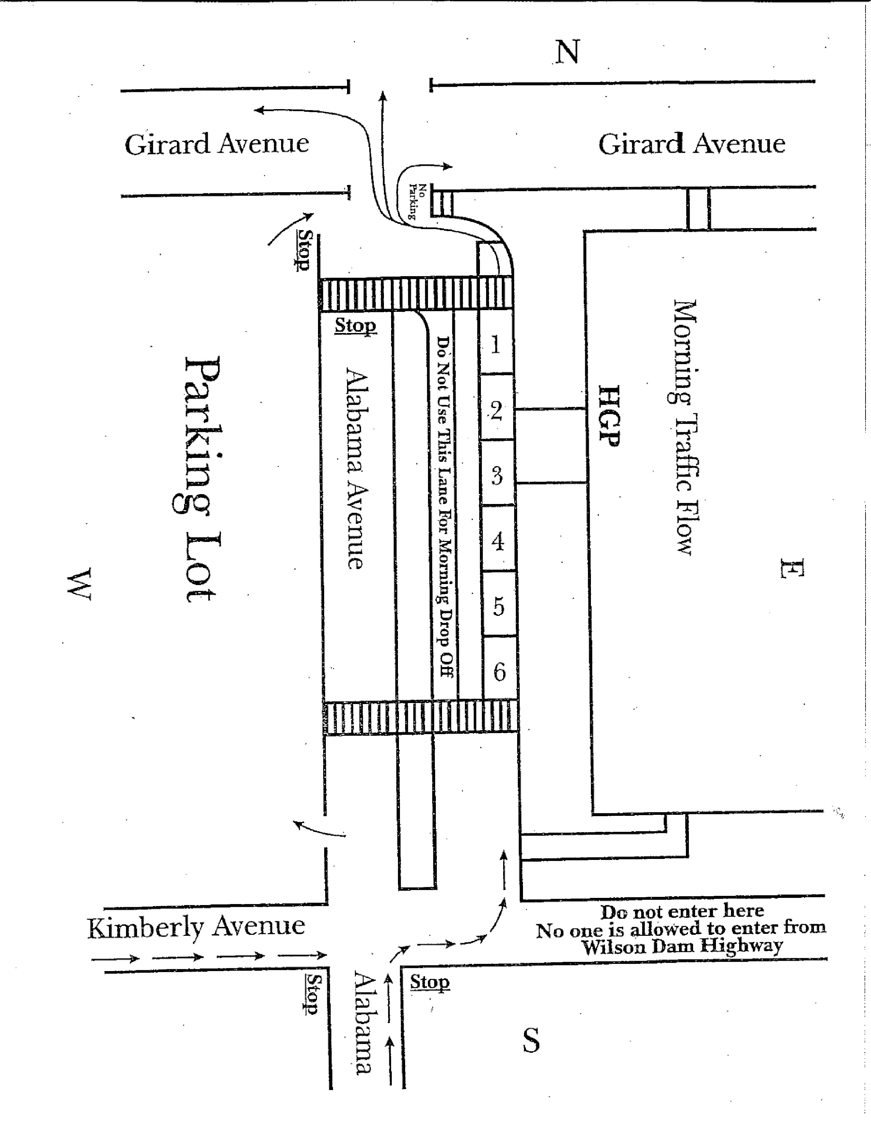
TELEPHONE MESSAGES

Our children's instruction is our first goal and thus we will not be able to interrupt classroom instruction unless it is an emergency. When you need to speak to your child's teacher, please call during the teacher’s planning time. If you cannot do this, please call the school office and a message will be given to the teacher or she will be asked to return your call.

TRAFFIC

One of the primary goals of Howell Graves Preschool is to provide a safe and caring environment for your child. You, too, can be a major contributor to our safe environment if you will abide by our traffic rules. If someone other than parents drop off or pick up a student, please make sure that person is aware of all of our traffic rules. This insures the safety of your child and also helps with our traffic flow. Also, the person picking up your child MUST have a security card.
MORNING TRAFFIC

In the mornings, we ask that you use only the right-hand lane of the drive through to drop off your child. We ask parents and students to always use the crosswalks and to NEVER walk between the parked cars. We also ask parents not to stop on Alabama Avenue and send their child unattended to the building. You may park in the parking lot across the street from Howell Graves and walk your child across.

We realize, too, that many parents need to be at work after dropping off their child. To assist working parents, we ask that you not linger in the drive through lane. Be sure your child is ready to leave your car with all necessary items in hand. After your child exits the car, please pay close attention to the crosswalks. Thanks for your help!

AFTERNOON TRAFFIC

In the afternoon, all teachers will assist in providing a safe pickup of each child. We have 12 parking spaces that will be loaded at one time. Red and yellow (stop and slow) signs will be used to signal students and parents. The red signs instruct cars to remain still and students to walk. The yellow signs signal cars to move slowly. Once all 12 cars are loaded, the traffic controller will blow her whistle and wave the cars through. At that point, 12 more cars move forward.

If you park your car in the front parking lot or on Alabama Avenue and walk to pick up your child, please use the crosswalks. Never walk between the cars. Please respect the teachers if they remind you not to do so.

Traffic flow charts for morning and afternoon are located on the following pages.
Traffic lanes in the front of the school will be blocked in the afternoon until 1:30 p.m.

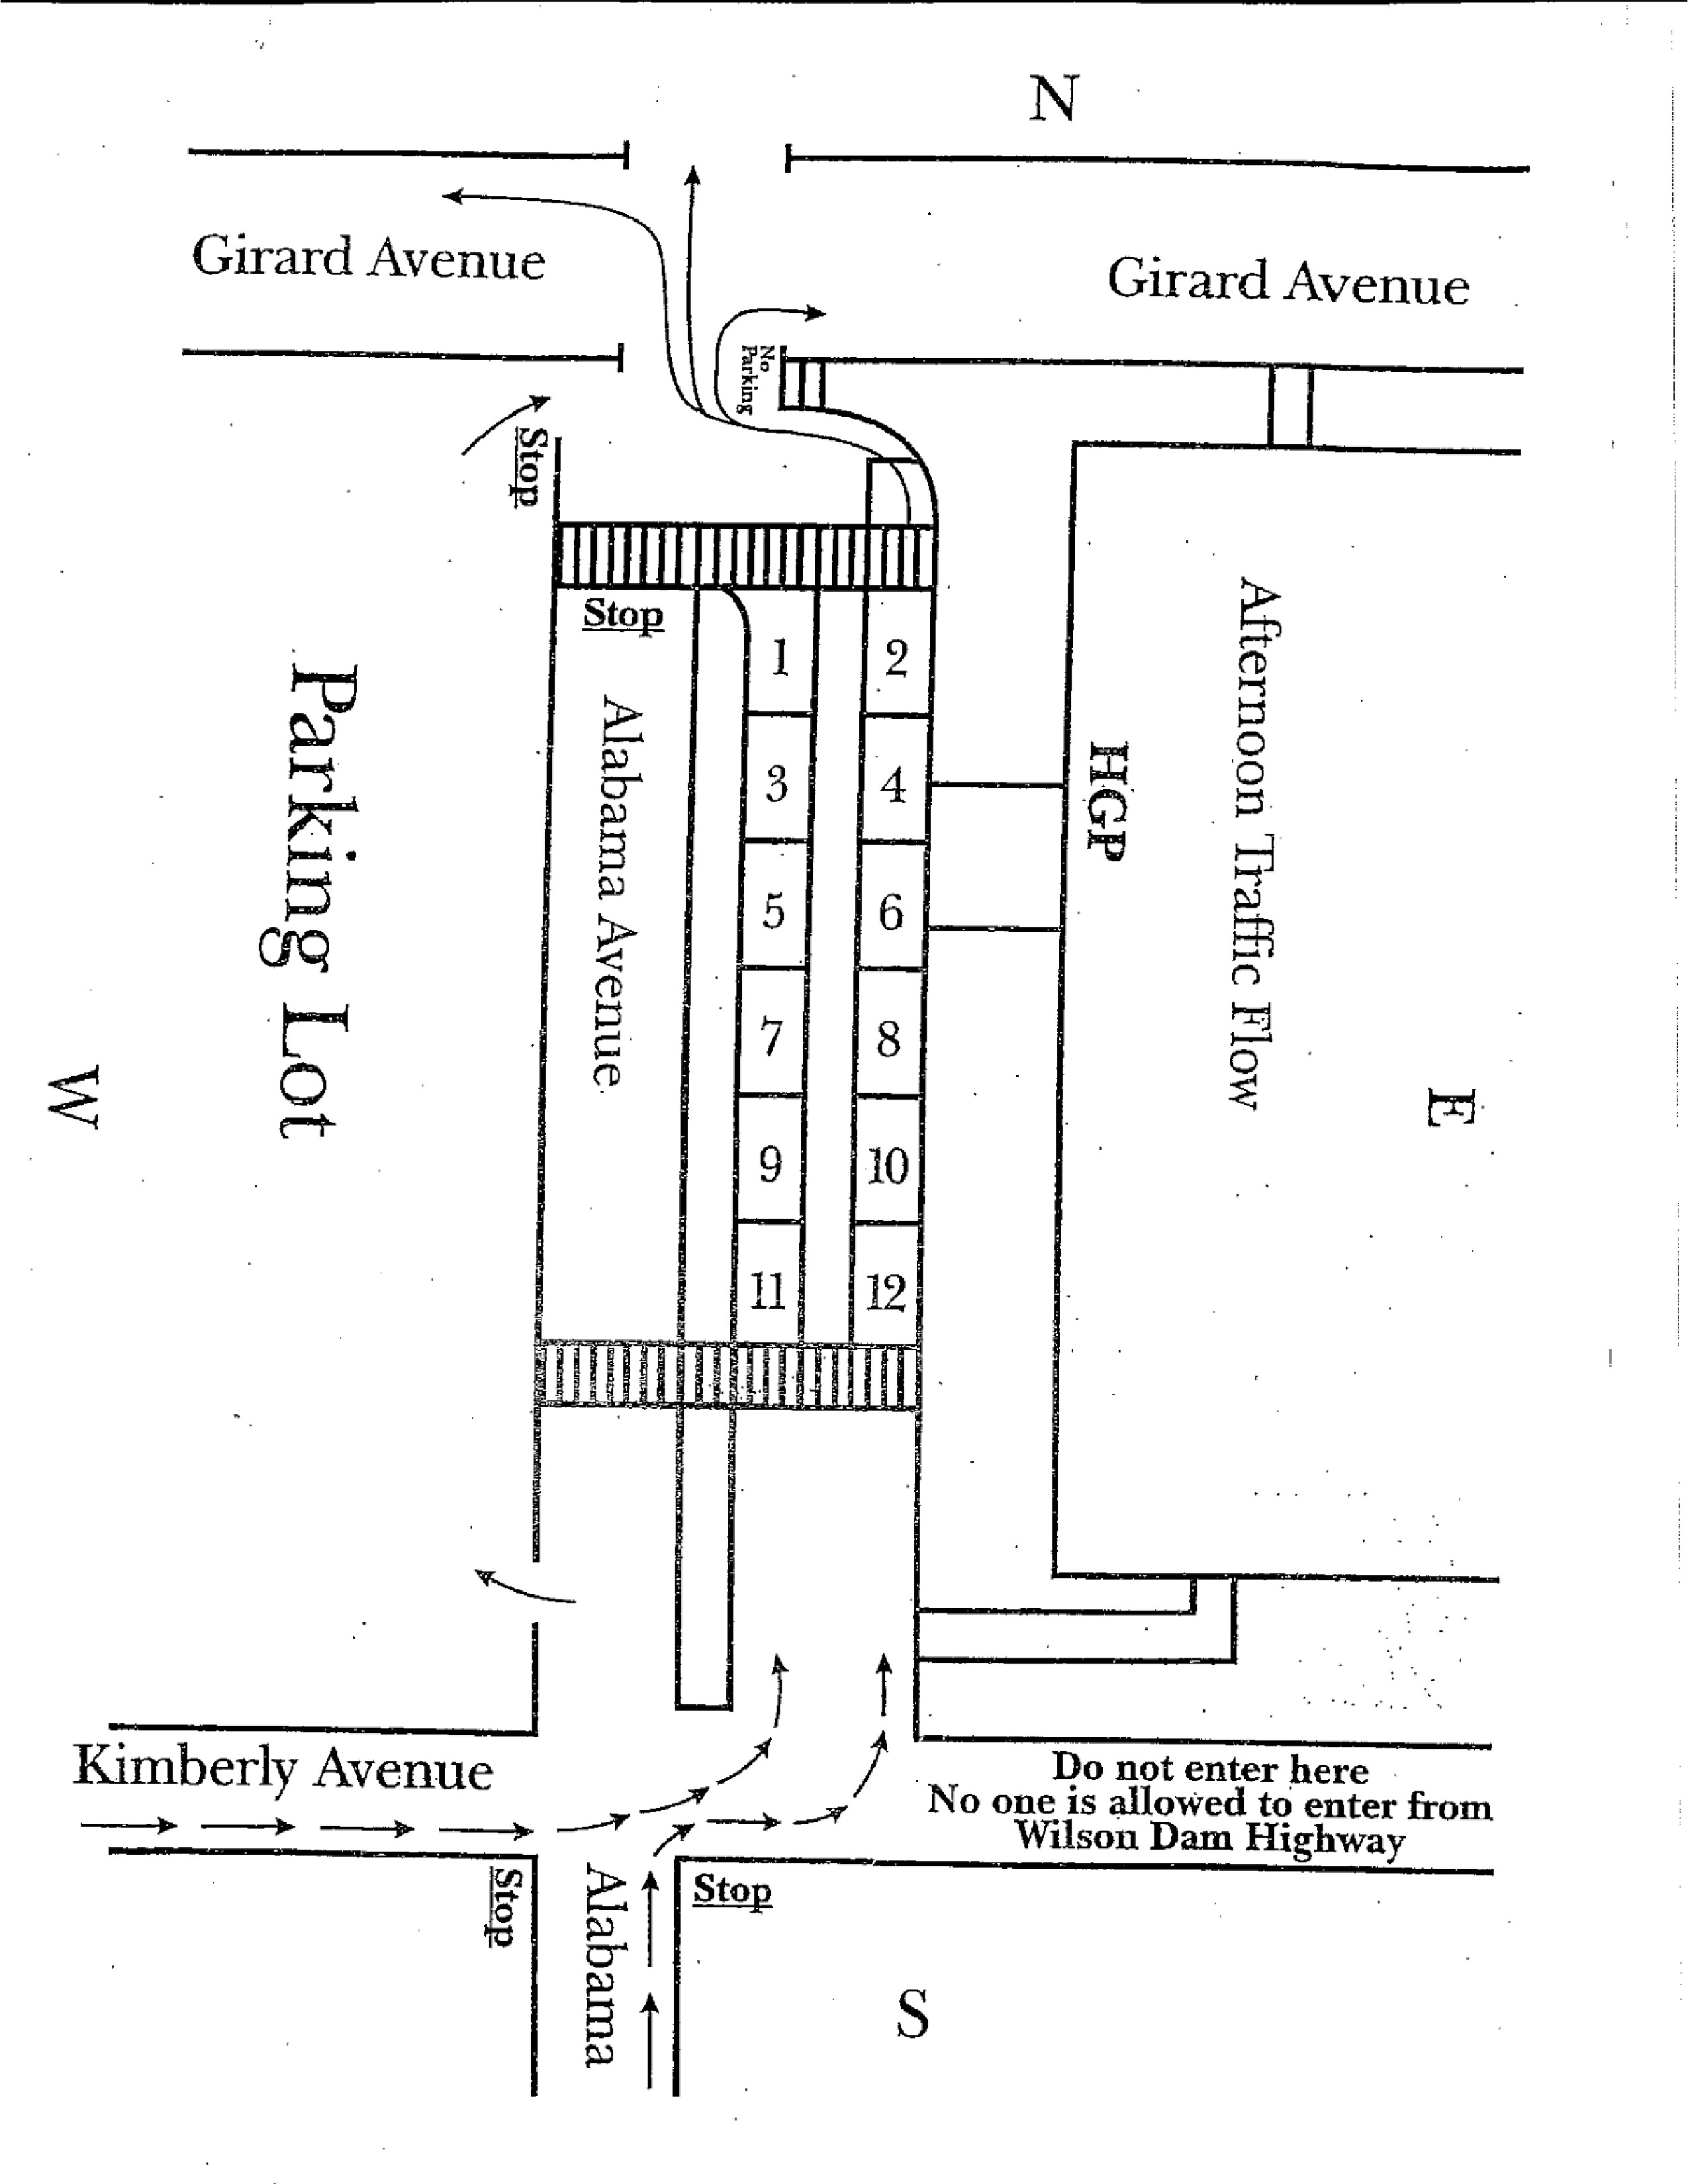
TROJAN SUPPORT
Each Friday morning during football/basketball season we will have spirit items for sale. We will send a price list of items before the first game. If you want your child to purchase one of these items, please put their money in an envelope with their name on it and the item(s) to be purchased.

T-SHIRTS
T-Shirts for Howell Graves Preschool will be sold each year at a price of $10.00 (this is included in the supply, party money, and t-shirt money). These shirts are to be worn when students attend field trips or participate in special activities.

V

VANDALISM
Students who intentionally commit acts of vandalism (deface or damage school equipment or property) will be required to clean and/or pay for damage done. The student may be subject to other disciplinary procedures.

VOLUNTEERS
Volunteers are always welcomed at Howell Graves Preschool. Please contact your child's teacher or the office if you are interested in sharing your time and talents. Be sure to pick up a visitor's pass.

W

WEAPONS
The Muscle Shoals Board of Education authorizes the superintendent or designated administrator to automatically suspend any student found to have a dangerous weapon (a dangerous weapon is defined as a knife, club, gun, chain, or any other object deemed dangerous by the superintendent) in their possession. This policy shall apply on all Muscle Shoals City Schools property (school buildings, school buses, etc.) and during any school sponsored event during or after regular school hours wherever located. Students violating this policy will be suspended and may be subject to further disciplinary action by school officials and possible legal action. As required by the Gun-Free School Act of 1994, any student bringing a weapon to school, as defined by Section 921 of Title 18 of the United State Code, will receive a recommendation for expulsion from school for at least one calendar year and the student will also be referred to the juvenile or criminal justice system.

WELLNESS PLAN
Foods of Minimal Nutritional Value (MNV), as defined by USDA, shall not be given or sold to students on campus during the school day. Foods of MNV include foods and beverages with sucrose, high fructose corn syrup, and other sugars listed as the first ingredient. Persons who bring foods from outside the school for student recognition, parties, and other group functions, and events shall be encouraged to take every measure to ensure that foods and beverages meet federal, state, and local laws and guidelines.
*Board Policy Vending and Snacks EHA
* Wellness ILA

WITHDRAWAL AND TRANSFER
The student or student's parent or legal guardian must request withdrawal of a student from the school office. The appropriate papers will be given to the parent or legal guardian. All other papers will be mailed to the school the student will be attending upon request of records from that school. Students are withdrawn from the statewide Powerschool system.
Compliance of State or Federal Regulations
Inquires or complaints regarding compliance with state or federal regulations may be directed to Title VI Coordinator – Denise Woods, Assistant Superintendent, Muscle Shoals Board of Education, 3200 Wilson Dam Road, P.O. Box 2610, Muscle Shoals, AL 35662 (256) 389-2600, Section 504 Coordinator and ADD-ADHD Education Coordinator – Dr. Matthew Carpenter, 3200 Wilson Dam Road, Muscle Shoals, AL 35661, (256)-389-2620 and Title IX Coordinator- Dr. Matthew Carpenter, Muscle Shoals Board of Education, 3200 Wilson Dam Road, Muscle Shoals, AL 35661, (256) 389-2682.

PARENT SIGNATURE PAGE

THIS PAGE IS TO BE SIGNED ELECTRONICALLY.

We believe that parental involvement and support is crucial to a child's success not only in school, but also in life. Parents and educators must work together to aid our children's mental, emotional, and physical development. Therefore, we enlist your support in the education of your child.

In order to provide all children at Howell Graves Preschool with an atmosphere conducive for learning, your support is necessary. Hence, we require you to read this handbook and discuss the pertinent information with your child.

Your signature certifies that you have read the information in this handbook and discussed it with your child.

